Consider Becoming a Pen Pal
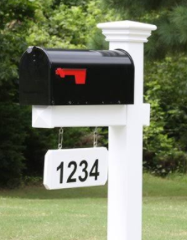
with an incarcerated UU

- Correspond with a fellow UU who lives in a United States prison
- Bring a message of hope and make a big impact in someone’s life
- Be one of hundreds of free-world pen pals who are at the heart of the CLF Prison Ministry
- Get the support you need for this safe, easy, and rewarding letter writing ministry
- Requires only a small commitment

Most CLF members in prison are new UUs and learned about the CLF from friends or cellmates. With no access to the web or UU Sunday services, people who are incarcerated can only learn about Unitarian Universalism from the mailings we send them and the letters they exchange with our staff and other Unitarian Universalists like you!
Our Director of Prison Ministry matches CLF members who are incarcerated with UUs who live in the free world. For a minimum of six months, you will exchange friendly letters on topics of mutual interest. All letter writers (incarcerated and “free-world”) agree to the same guidelines, which emphasize that our program is not intended for romantic, legal-aid or financial/gift interactions.
All letters from your letter-writing partner go to the CLF office, and we mail them to you. In other words no mail is sent directly to you from a prison or jail; it all passes through our office first.
Learn more here - https://worthynow.org/pen-pals/

